INDEX

Sr No. | Date | Practical Name | Sign
1. |  | Write a program to take backup of mysql database
2. |  | Write a program to restore mysql database
3. |  | Use DriveImage XML to image a hard drive
4. |  | Write a program to create a log file
5. |  | Write a program to find a file in a directory
6. |  | Write a program to find a word in a file
7. |  | Create forensic images of digital devices from volatile data such as memory using Imager for: (i) Computer System; (ii) Server; (iii) Mobile Device
10. |  | Create a new investigation case using Forensic Tool:  (i) Computer System; (ii) Computer Network; (iii) Mobile Device ;(iv) Wireless Network.

PRACTICAL NO: 1
Aim: Write a program to take backup of mysql database

INPUT:-

import java.io.IOException;
public class backup {
public static void main(String[] args)
{
String host = "localhost";
String port = "3306";
String databaseName = "employee";
String username = "root";
String password = "12345";
String backupPath = "D:\\Folder/backup.sql";
backupMySQLDatabase(host, port, databaseName, username, password, backupPath);
}
public static void backupMySQLDatabase(String host, String port, String databaseName, String username, String password, String backupPath)
{
try {
String command = "mysqldump -h " + host + " -P " + port + " -u " + username + " -p" + password + " " + databaseName + " -r " + backupPath;
ProcessBuilder processBuilder = new ProcessBuilder("cmd.exe", "/c", command);
Process process = processBuilder.start();

int exitCode = process.waitFor();
if
(exitCode == 0) {
System.out.println("Backup completed successfully.");
} else {
System.out.println("Backup failed. Please check the error message.");
}
} catch (IOException | InterruptedException e) {}
}
}
Note :
Make sure to replace placeholders like "your_database_name", "your_username", "your_password", and "path_to_backup_directory" with your actual MySQL database details.

OUTPUT:-

If the backup is successful:
Backup completed successfully.

If there is an error during the backup process: Backup failed. Please check the error message.

PRACTICAL NO: 2
Aim: Write a program to restore mysql database

INPUT:-
import java.io.IOException;
public class MySQLRestore {
public static void main(String[] args)
{
String host = "localhost";
String port = "3306";
String databaseName = "employee";
String username = "root";
String password = "12345";
String backupPath = "D:\\Folder/backup.sql";
restoreMySQLDatabase(host, port, databaseName, username, password, backupPath);
}
public static void restoreMySQLDatabase(String host, String port, String databaseName, String username, String password, String backupPath)
{
try {
String command = "mysql -h " + host + " -P " + port + " -u " + username + " -p" + password + " " + databaseName + " < " + backupPath;

ProcessBuilder processBuilder = new ProcessBuilder("cmd.exe", "/c", command);
Process process = processBuilder.start();

int exitCode = process.waitFor(); if (exitCode == 0) {
System.out.println("Database restore completed successfully.");
} else {
System.out.println("Database restore failed. Please check the error message.");
}
} catch (IOException | InterruptedException e) {}
}
}
Note: Replace placeholders like "your_database_name", "your_username", "your_password", and "path_to_backup_directory" with your actual MySQL database details.

OUTPUT:-

If the restore is successful:
Database restore completed successfully

If there is an error during the restore process:
Database restore failed. Please check the error message

PRACTICAL NO: 3
Aim: Use DriveImage XML to image a hard drive

INPUT:-
Note : This program assumes you have already installed DriveImage XML on your system.

import java.io.BufferedReader; import java.io.IOException; import java.io.InputStreamReader;

public class DriveImageXMLExample {

public static void main(String[] args) {
// Replace these values with your actual DriveImage XML installation path and desired image file
path
String driveImageXMLPath = "C:\\Program Files\\Runtime Software\\DriveImage
XML\\dixml.exe";
String sourceDrive = "C:"; // Replace with the drive you want to image
String destinationImagePath = "D:\\backup_image.xml"; // Replace with the desired image file
path

// Create a disk image
createDiskImage(driveImageXMLPath, sourceDrive, destinationImagePath);
// Restore from the disk image (optional)
// restoreFromDiskImage(driveImageXMLPath, destinationImagePath, "E:"); // Replace with the destination drive
}

public static void createDiskImage(String driveImageXMLPath, String sourceDrive, String destinationImagePath) {

try {
String command = driveImageXMLPath + " /b /v /c /s" + sourceDrive + " /f" + destinationImagePath;

ProcessBuilder processBuilder = new ProcessBuilder("cmd.exe", "/c", command); Process process = processBuilder.start();

int exitCode = process.waitFor(); if (exitCode == 0) {
System.out.println("Disk image created successfully.");

} else {
System.out.println("Disk image creation failed. Please check the error message.");

printErrorStream(process);
}

} catch (IOException | InterruptedException e) { e.printStackTrace();
}
}

public static void restoreFromDiskImage(String driveImageXMLPath, String sourceImagePath,

String destinationDrive) { try {
String command = driveImageXMLPath + " /r /f" + sourceImagePath + " /s" + destinationDrive;

ProcessBuilder processBuilder = new ProcessBuilder("cmd.exe", "/c", command); Process process = processBuilder.start();

int exitCode = process.waitFor(); if (exitCode == 0) {
System.out.println("Restoration from disk image completed successfully.");
} else {

System.out.println("Restoration from disk image failed. Please check the error message."); printErrorStream(process);
}

} catch (IOException | InterruptedException e) { e.printStackTrace();
}
}
private static void printErrorStream(Process process) throws IOException { try (BufferedReader reader = new BufferedReader(new
InputStreamReader(process.getErrorStream()))) { String line;
System.out.println("Error message:"); while ((line = reader.readLine()) != null) {
System.out.println(line);

}
}
}
}

OUTPUT:-

Disk image created successfully.

PRACTICAL NO: 4
Aim: Write a program to create a log file.

INPUT:-

import java.io.IOException;
import java.util.logging.FileHandler;
import java.util.logging.Level;
import java.util.logging.Logger;
import java.util.logging.SimpleFormatter;

public class LogFileExample {

public static void main(String[] args) {
Logger logger = Logger.getLogger(LogFileExample.class.getName());

try {
// Create a file handler to write log messages to a file
FileHandler fileHandler = new FileHandler("example.log");

// Create a simple text formatter for the log records
SimpleFormatter simpleFormatter = new SimpleFormatter(); fileHandler.setFormatter(simpleFormatter);

// Add the file handler to the logger
logger.addHandler(fileHandler);

// Set the logging level (FINEST, FINER, FINE, INFO, WARNING, SEVERE)
logger.setLevel(Level.INFO);

// Log some sample messages
logger.info("This is an informational message.");
logger.warning("This is a warning message.");
logger.severe("This is a severe error message.");

}
catch (IOException e) {}
}
}

Note : Compile and run this program, and you should see a new file ( | example.log | ) created in the
project directory with the logged messages.

OUTPUT:-

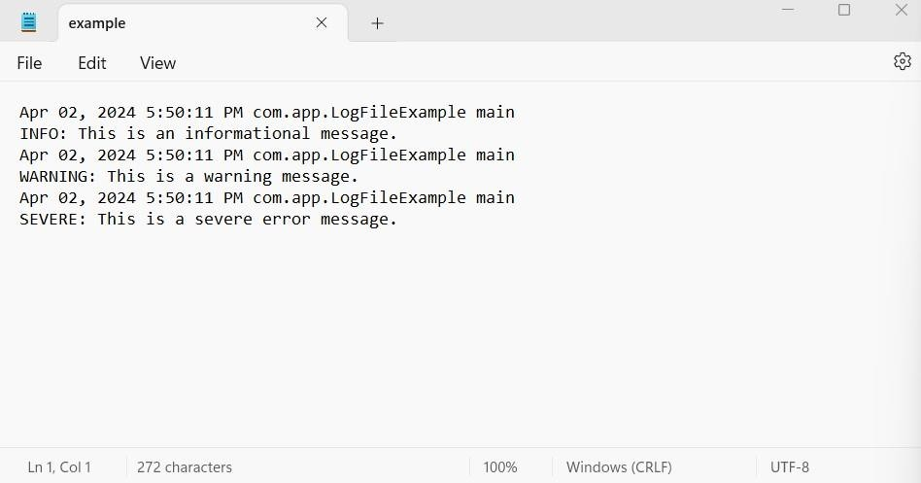

PRACTICAL NO: 5
Aim: Write a program to find a file in a directory

INPUT:-

a)
// Java Program to Search for a File in a Directory import java.io.*;
// MyFilenameFilter class implements FilenameFilter
// interface
class MyFilenameFilter implements FilenameFilter
{
String initials;
// constructor to initialize object
public MyFilenameFilter(String initials)
{
this.initials = initials;
}

// overriding the accept method of FilenameFilter
// interface
@Override
public boolean accept(File dir, String name)
{
return name.startsWith(initials);
}
}
public class Main {
public static void main(String[] args)
{
// Create an object of the File class
// Replace the file path with path of the directory
File directory;
directory = new File("C://12th Pracc File//SOP5//index.html");

// Create an object of Class MyFilenameFilter
// Constructor with name of file which is being
// searched
MyFilenameFilter filter = new MyFilenameFilter("file.cpp");

// store all names with same name
// with/without extension
String[] flist = directory.list(filter);
// Empty array
if (flist == null) {
System.out.println(
"Empty directory or directory does not exists.");
}
else {

// Print all files with same name in directory
// as provided in object of MyFilenameFilter
// class
for (int i = 0; i < flist.length; i++)
{
System.out.println(flist[i]+" found");
}
}
}
}
b)
// Java Program to Search for a File in a Directory import java.io.File;

public class Main {
public static void main(String[] argv) {
// Create an object of the File class
File directory = new File("D:/New folder");

// Store all file names in an array
String[] flist = directory.list();
boolean flag = false;

if (flist == null) {
System.out.println("Empty directory or directory not found.");
} else {
// Linear search in the array
for (String filename : flist) {
if (filename.equalsIgnoreCase("Textfile.txt")) {
System.out.println(filename + " found");
flag = true;

break; // Stop searching after finding the file
}
}

if (!flag) {
System.out.println("File Not Found");
}
}
}
}

OUTPUT:-

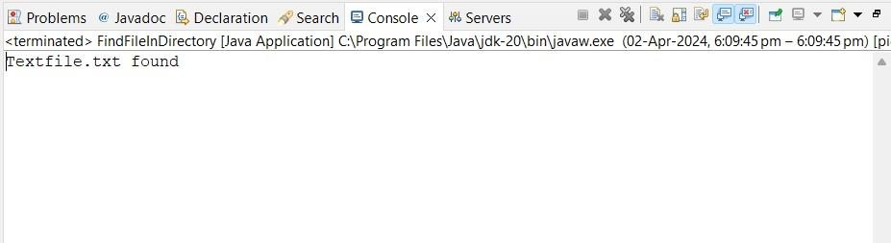

PRACTICAL NO: 6
Aim: Write a program to find a word in a file.

INPUT:-

import java.io.IOException;

import java.nio.file.Files;

import java.nio.file.Path;

import java.nio.file.Paths;

import java.util.Scanner;

public class FindWordInFile {

public static void main(String[] args) {

// Replace "path/to/your/file.txt" with the actual path to your text file

String filePath = "C:\\Users\\Aqsa Ulde\\OneDrive\\Documents\\NetBeansProjects\\FindWordInFile\\src\\example.log";

String targetWord = "WARNING";

try {

boolean wordFound = searchWordInFile(filePath, targetWord);

if (wordFound) {

System.out.println("The word '" + targetWord + "' was found in the file.");

} else {

System.out.println("The word '" + targetWord + "' was not found in the file.");

}

} catch (IOException e) {

}

}

public static boolean searchWordInFile(String filePath, String targetWord) throws IOException {

Path path = Paths.get(filePath);

// Check if the file exists

if (!Files.exists(path)) {

System.out.println("File not found: " + filePath);

return false;

}

try (Scanner scanner = new Scanner(path)) {

// Iterate through each line of the file

while (scanner.hasNextLine()) {

String line = scanner.nextLine();

// Check if the target word is present in the line

if (line.contains(targetWord)) {

return true; // Word found

}

}

}

return false; // Word not found

}

}

OUTPUT:-

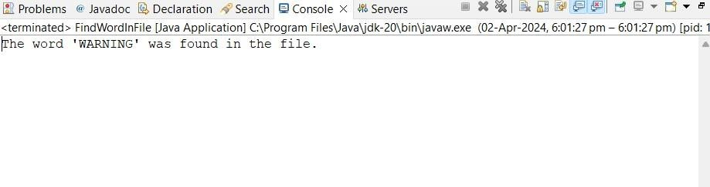

PRACTICAL NO: 7

Aim: Create forensic images of digital devices from volatile data such as memory using Imager for: (i) Computer System; (ii) Server; (iii) Mobile Device.

Using FTK Imager:
FTK Imager is a graphical tool that provides a user-friendly interface for creating forensic images. It's available for Windows and Linux.
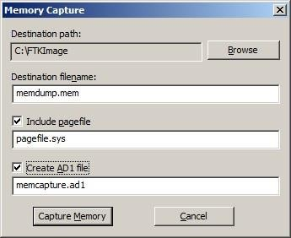
Download and install FTK Imager: AccessData FTK Imager. Open FTK Imager and go to File > Capture Memory.

Choose the target device, set the destination path, and click Start to create a memory image.

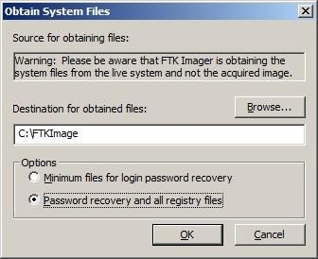

PRACTICAL NO: 10

Aim: Create a new investigation case using Forensic Tool: (i) Computer System; (ii) Computer Network; (iii) Mobile Device; (iv) Wireless Network.

INPUT:-

- Computer System:
Forensic Tool: Autopsy
Download and Install Autopsy: Autopsy Open Autopsy and create a new case.
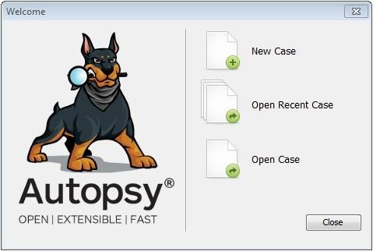
Enter case details, such as case name, case number, and investigator information.

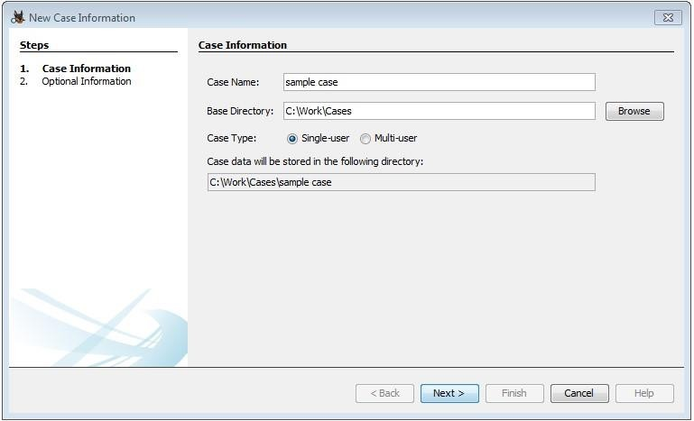

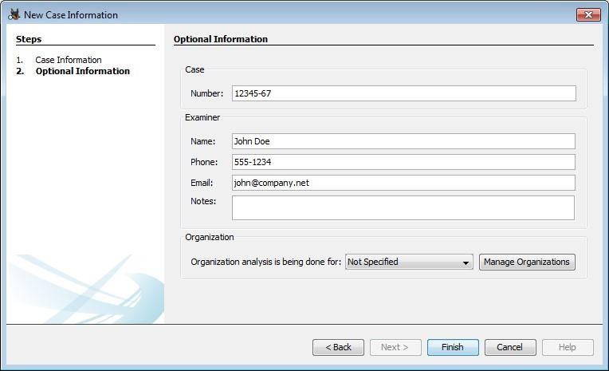
Add a data source for the computer system (e.g., a disk image).
Start the analysis to examine file systems, recover deleted files, and explore system artifacts.

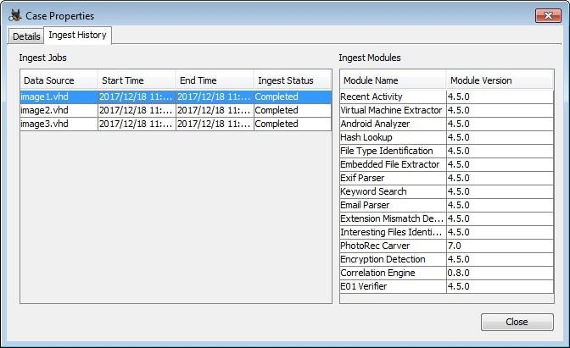

- Computer Network:
Forensic Tool: Wireshark
Download and Install Wireshark: Wireshark
Capture network traffic using Wireshark on the suspect system. Save the captured data to a file (PCAP format).
Open Wireshark and load the captured file.
Analyze the network traffic for any suspicious activities, such as unauthorized access or data exfiltration.

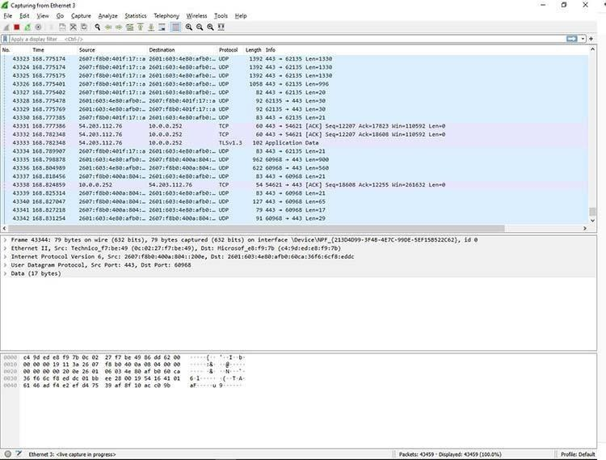

- Mobile Device:
Forensic Tool: Cellebrite UFED (Universal Forensic Extraction Device) Acquire a Cellebrite UFED device or use the software version.
Connect the mobile device to the UFED device or software.
Follow the steps to create a new case in UFED.
Perform a forensic extraction of the mobile device's data.
Analyze the extracted data for evidence related to the investigation.
- Wireless Network:
Forensic Tool: Aircrack-ng
Download and Install Aircrack-ng: Aircrack-ng

Capture wireless network traffic using Aircrack-ng tools like airodump-ng. Save the captured data to a file.
Use tools like aircrack-ng to analyze the captured data and crack WEP/WPA keys if necessary. Investigate any suspicious wireless network activities.

